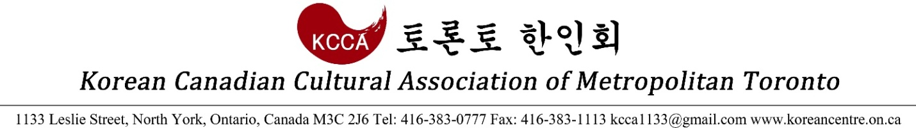

2017 Lunar Festival – Hanbok Contest Application

Child – 0 ~ 12

Name (Sex): ______________________ (M □ / F □)
Birth date (Age): _______________ (____ years old)
Phone: ____________________
E-mail: ______________________
Notes/Comments:

There will be a group of judges who will score the contestants, and highest scorers will receive appropriate prizes.

Thank you.

Korean Canadian Cultural Association
P: 416-383-0777
E: kcca1133@gmail.com

