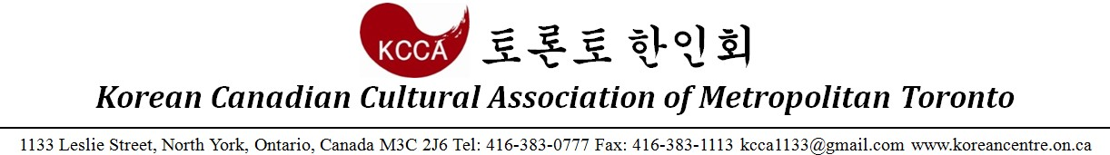

2017 Peace Run Group Registration Form

- I for myself, my heirs, executors, administrators, successors and assigns, HEREBY RELEASE WAIVER AND FOREVER DISCHARGE The City of Toronto, The Toronto Police Services Board, The Toronto Police Service, The Members of the Toronto Police Service Auxiliary Program, The Chief of Police, The Toronto Transit Commission, Korean Canadian Cultural Association, The Korea Times Daily and all other association, sanctioning bodies and sponsoring companies, and all their respective agents, officials and servants from claims, demands, damages, costs, expenses, actions and causes of action, whether in law or equity, in respect of death, injury, loss or damage to my person or property HOWSOEVER CAUSED rising or to arise by reason of my participation in the said event, whether as a spectator, participant, competitor or otherwise, whether prior to, during or subsequent to the event, AND NOTWITHSTANDING that same may have been contributed to, or occasioned by, the negligence of any of the aforesaid.
- I FURTHER HEREBY UNDERTAKE or HOLD AND SAVE HARMLESS and AGREE TO INDEMNIFY all of the aforesaid from and against any and all liability incurred by any or all of them as a result of, or in anyway connected with, my participation in the said event.
- BY SUBMITTING THIS ENTRY, I ACKNOWLEDGE HAVING READ, UNDERSTOOD AND AGREED TO THE ABOVE WAIVER, RELEASE AND INDEMNITY. I
WARRANT that I am physically fit to participate in this event.

Group Entry Fee |  | 10K Run : $15, 5K Run / Walk: $10 (10+ Participants)
Organization Information
Org. Name
Org. Address |  | Street: Unit:
 |  | City: Province: Postal Code:
Contact Information |  | Representative:
 |  | Phone Number:
 |  | Email:
 | Name | Phone Number | Sex | Age | Marathon Type |  |  | 10K/5K Run & 5K Walk Estimated Race Time | Signature
 |  |  |  |  | 10K  Run | 5K  Run | 5K  Walk
1
2
3
4
5
6
7
8
9
10

Cheque Payable to: KCCA
Please complete and submit this form by September 15th, Friday via email to: kcca1133@gmail.com

