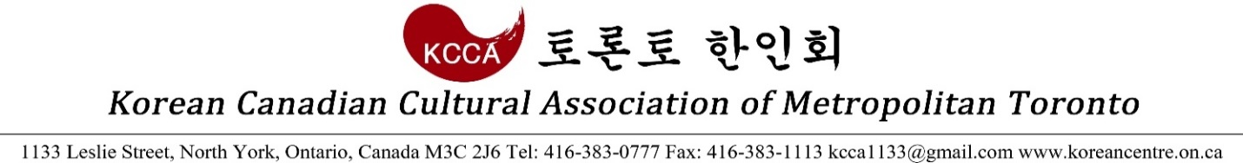
<2017 Lunar New Year Festival Team Games Application>

Team Games
Yutnori (3 members/team) & Arm Wrestling (2F, 2M/team)
Participation Fees
$100/Game ($150 if participating in both)

Name of Team/Organization |  | Date of Application
Phone |  | E-mail
Participating Game(s) |  | Fee
Payment Method |  | Note

Application Deadline: Monday, January 30, 2017
Thank you for participating in the team games at 2017 Lunar New Year Festival. Please forward any questions and concerns to the KCCA Office.

KCCA Office
416-383-0777
kcca1133@gmail.com

